**Master-Slave Setup**

**Slave-01**

Provision an EC2 Linux instance in AWS.

Allocate and associate an ElasticIP to your EC2 instance.

Be sure to allow the ElasticIp address to be reallocated in case you need to change the VPC or Subnets.

**Security Group**

Port 8080 open for internet

Port 22 open for SSH

**Software Installation**

**======================**

Java 17 or 11

**Setup Jenkins Slave**

**=======================**

sudo su

mkdir home

ls

cd home

mkdir jenkins-slave-01

ls

# Create user and add the user to wheel group

useradd jenkins-slave-01

# Create SSH Keys

sudo su - jenkins-slave-01

ssh-keygen -t rsa -N "" -f /home/jenkins-slave-01/.ssh/id_rsa

# The private and public keys will be created at these locations `/home/jenkins-slave-01/.ssh/id_rsa` and `/home/jenkins-slave-01/.ssh/id_rsa.pub`

cd .ssh

cat id_rsa.pub > authorized_keys

chmod 700 authorized_keys

more id_rsa

**Configuration on Master**

==============================

Provision an EC2 Linux instance in AWS.

Allocate and associate an ElasticIP to your EC2 instance.

Be sure to allow the ElasticIp address to be reallocated.

**Security Group**

**==============================**

Port 8080 open for internet

Port 22 open for SSH

**Software Installation**

**======================**

Java 17 or 11

Git

Jenkins

**Master Node’s Known Hosts**

**=========================**

**Copy the slave node's public key[id_rsa.pub] to Master Node's known_hosts file**

sudo su

mkdir -p /var/lib/jenkins/.ssh

cd /var/lib/jenkins/.ssh

***ssh-keyscan -H SLAVE-NODE-IP-OR-HOSTNAME >>/var/lib/jenkins/.ssh/known_hosts***

# ssh-keyscan -H 54.221.234.133 >>/var/lib/jenkins/.ssh/known_hosts

chown jenkins:jenkins /var/lib/jenkins/.ssh/known_hosts

chmod 700 /var/lib/jenkins/.ssh/known_hosts

**Restart Master and Slave EC2 instances**

**Configure the Master and Slave Nodes using Manage Jenkins**

**Master Node**

**==============**

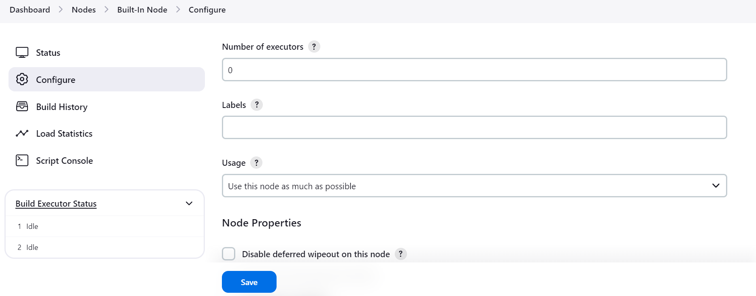

**Slave-01 Node**

Create a New Node and configure it as below.

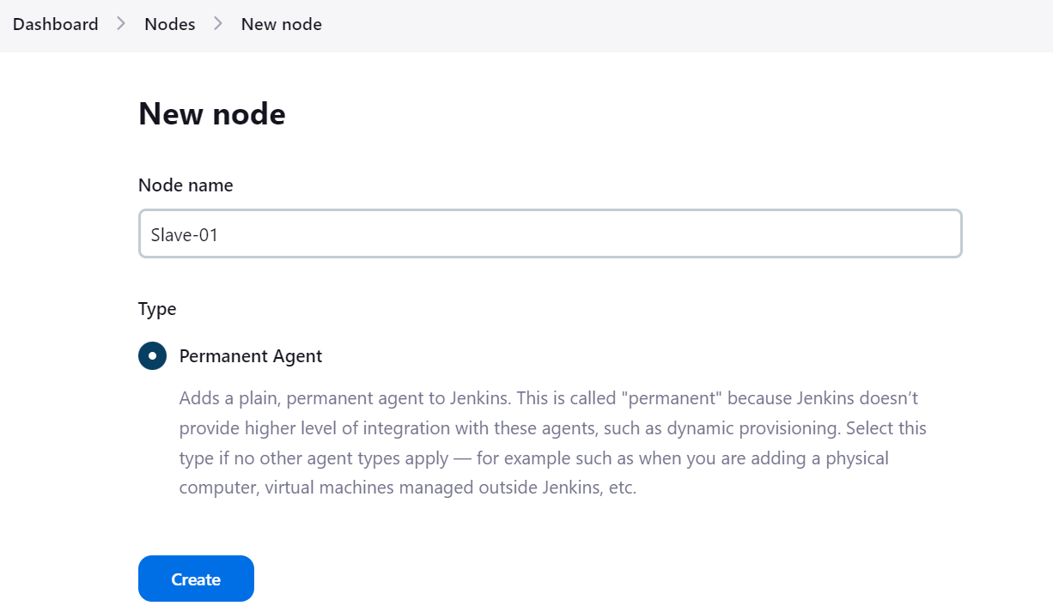

Enter the details as shown in the image below and save them.

The credentials to be configured are shown in the next few screenprints.

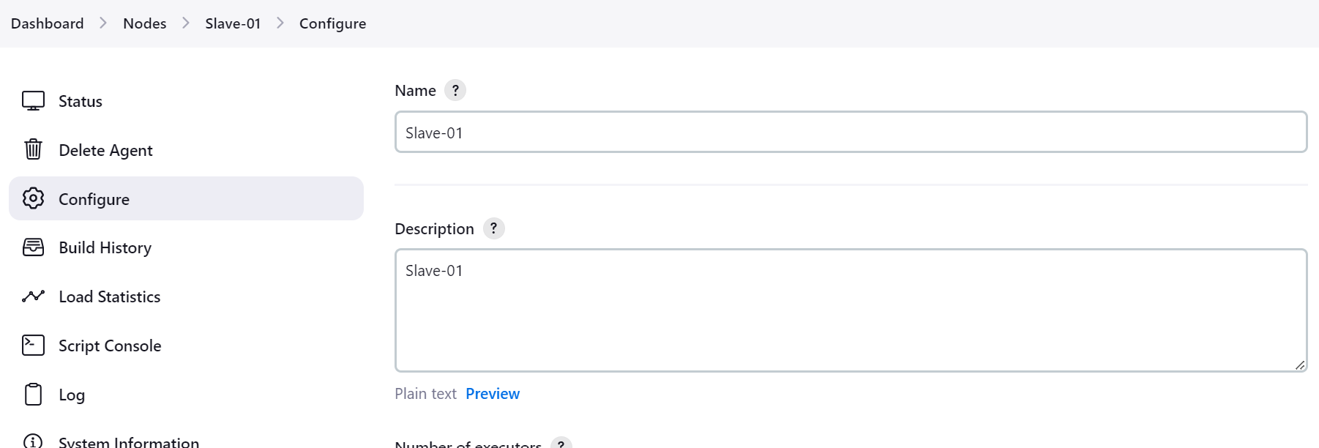

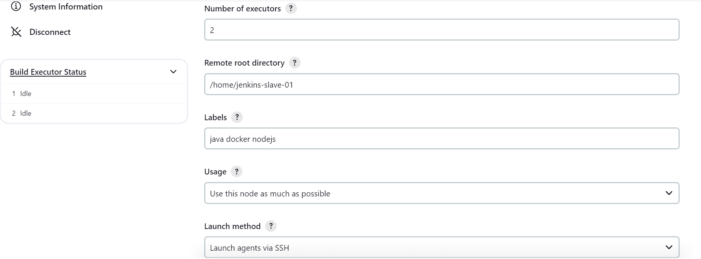

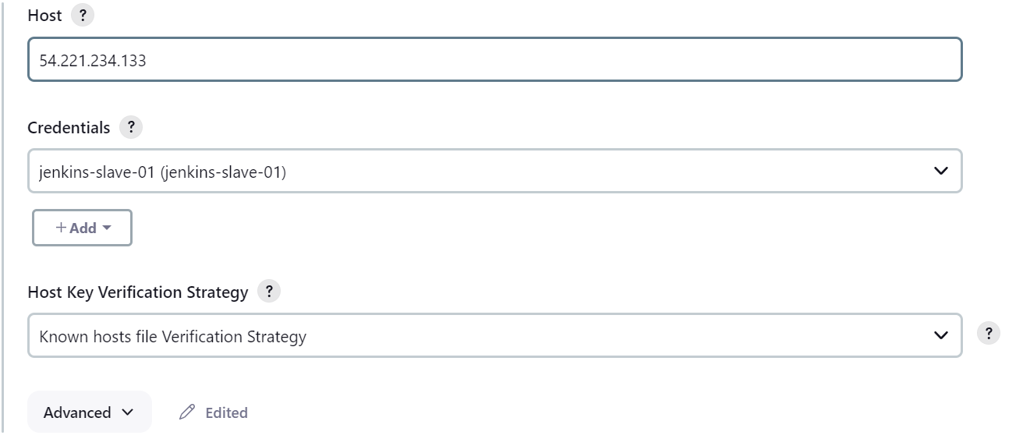

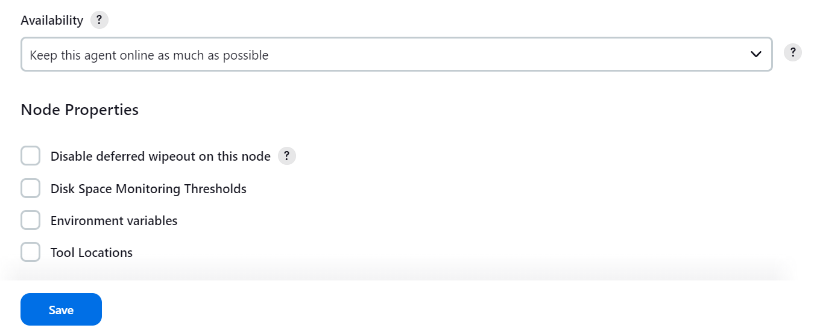

**Configure incoming requests to Jenkins Master Node**



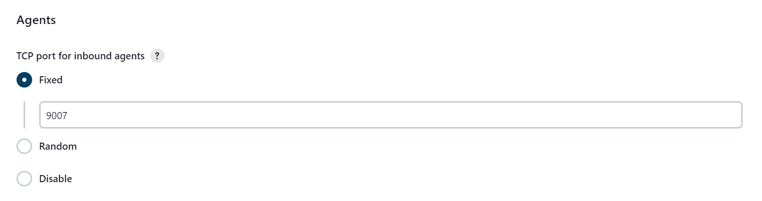

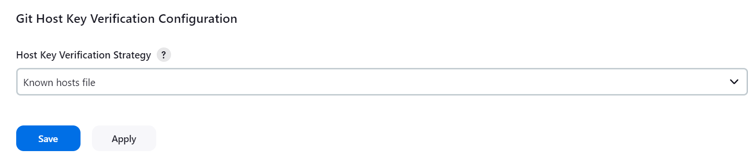

**Add the SSH Private Key to Jenkins Credentials**

On Slave Node, retrieve the SSH private key.

[ec2-user@ip-172-31-21-110 ~]$ sudo su - jenkins-slave-01

[jenkins-slave-01@ip-172-31-21-110 ~]$ cd .ssh

[jenkins-slave-01@ip-172-31-21-110 .ssh]$ more id_rsa

Go to Jenkins dashboard –> credentials –> Global credentials –> add credentials, select and enter all the credentials as shown below and click ok.

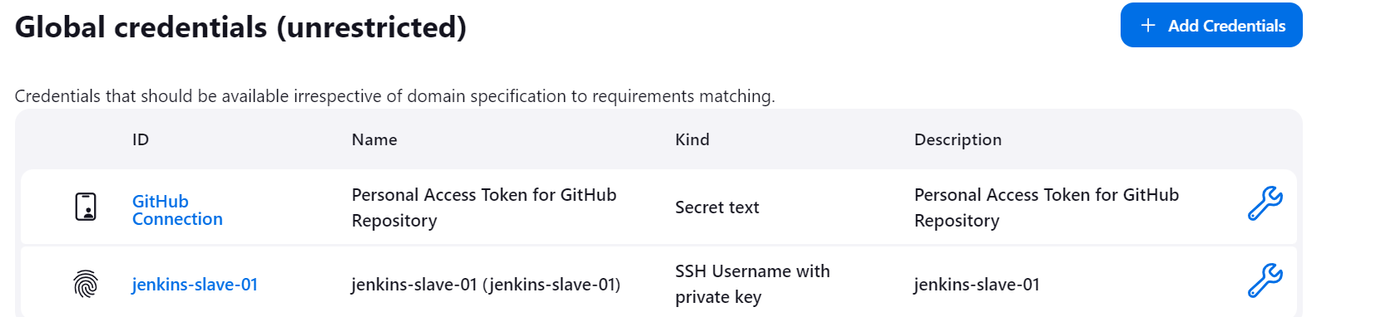 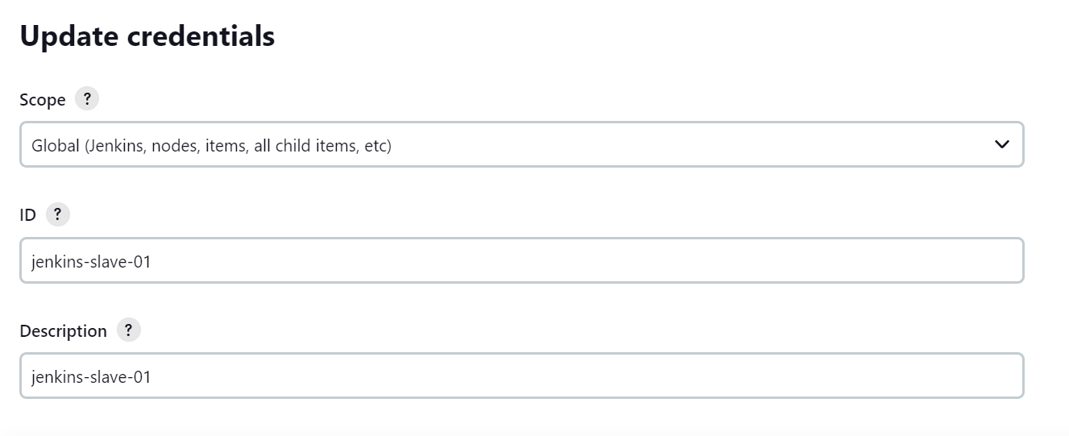

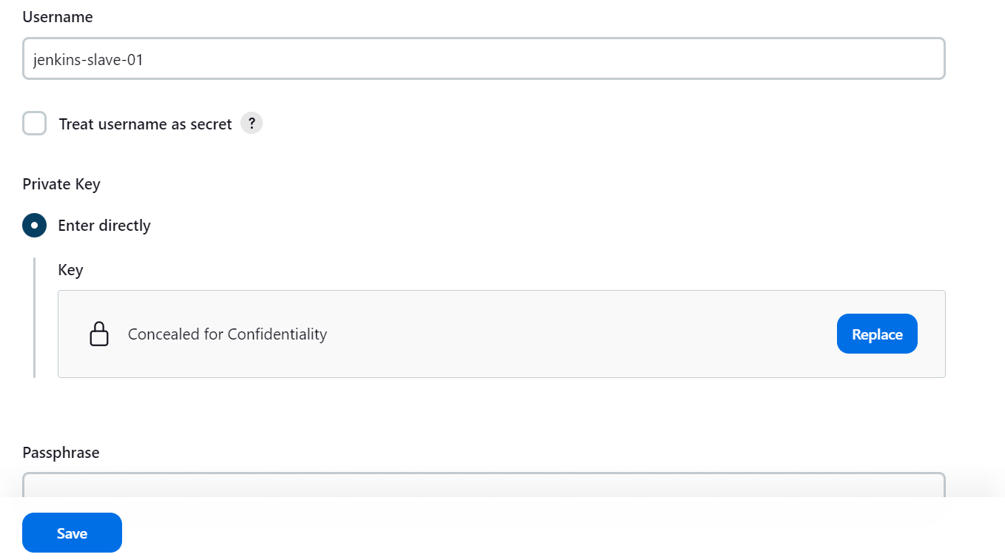



**Enter the private key obtained from Slave Node EC2 instance.**

**If configured correctly, this will display in the Nodes section under Manage Jenkins: -**

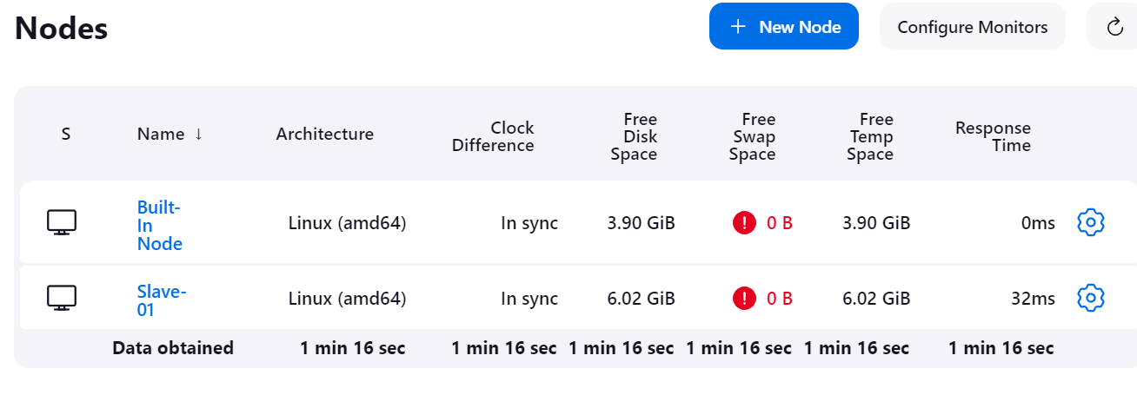

## Test Jenkins Agent/Slave Nodes

To test the Jenkins agent node or slave, create a sample pipeline project and select the option as shown below.



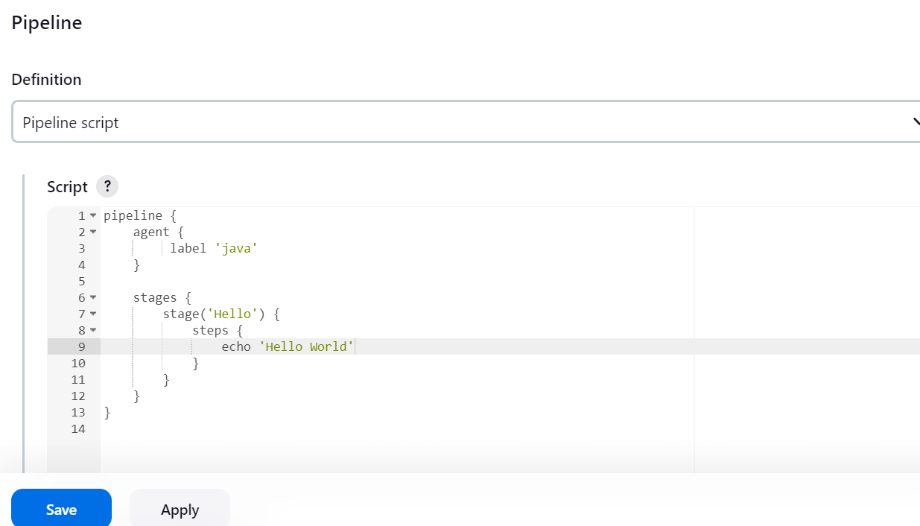

pipeline {

agent {

label 'java'

}

stages {

stage('Hello') {

steps {

echo 'Hello World'

}

}

}

}

**Console output should be as follows: -**

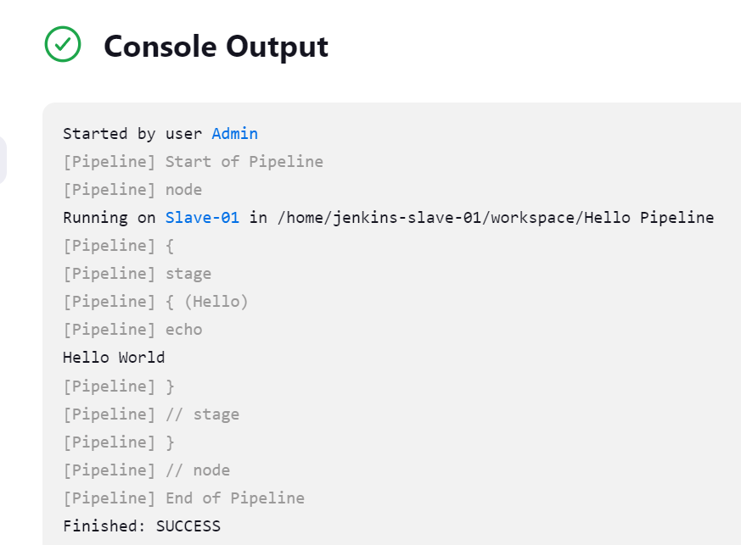

Note: It's not possible to move an existing instance to another subnet, Availability Zone, or VPC. Instead, you can create a new Amazon Machine Image (AMI) from the source instance to manually migrate the instance. Next, use the new AMI to launch a new instance in the desired subnet, Availability Zone, or VPC. And finally, reassign any Elastic IP addresses from the source instance to the new instance.

***********************************************************************************************************